**Technical Documentation – Deploy Execute Harness Workflow**

1. Workflow – Deploys and executes the Oracle Harness to an Environment.

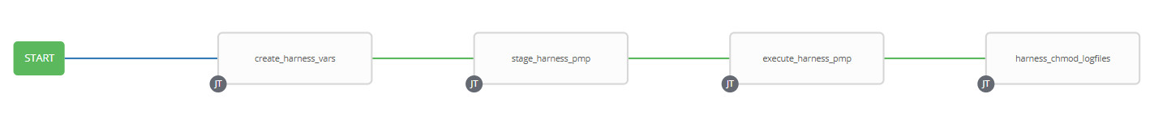

1. Survey – User Supplied Variables

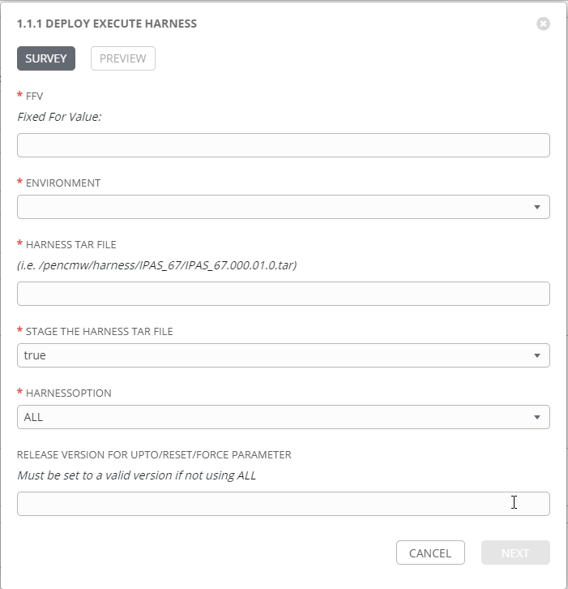

|  |  |  |  |
| --- | --- | --- | --- |
| **Survey Extra Variables** | **Prompt** | **Type** | **Description and Usage** |
| FFV | Fixed For Value | Text | The fixed for value for the deployment – must be of the format ###.###.###.### (i.e. 58.0.12.0). Numbers only, with a maximum of 3 digits and there must be 4 sets separated with a ‘.’. Used to create staging and deployments directories. Used by all job templates in the workflow |
| ENV | Deploy to Which Environment | Multiple Choice Single Pick | The Environment to Deploy to: DEVL, DEV3, RDEV, TST1, TST2, TST3, MUAT, IPASP. Only a single environment can be deployed to per workflow execution |
| Harness_Tar_File | Harness TAR File | Text |  |
| STAGE | Stage the Harness TAR File | Multiple Choice Single Pick | True or false – Copies the Business Artifacts from the MOS Build Releases Directory to the Staging folder. |
| HarnessOption | HarnessOption | Multiple Choice Single Pick | The /pencmw_common/MOS/releases/ subdirectory that contains the business services artifacts |
| UptoResetForceVersion | Release Version for UPTO/RESET/FORCE Parameter | Text |  |

1. Jobs Used by the workflow - http://owl.penc.local:18080/svn/deploy_automation/trunk/Ansible_PlayBooks/MOS

| **Job Template** | **Ansible Playbook** | **Credential / host** | **Project** | **Description and Usage** |
| --- | --- | --- | --- | --- |
| create_services_vars | create_inc_services_vars_ansible.yml  Calls:  set_services_restart_all.yml | None – runs on localhost as awx linux user | MOS/MEX Deployments | create_inc_servcies_vars_ansible.yml – Creates Variables/Artifacts for use within the workflows, based on the User supplied survey results.  Artifacts Defined with examples  DeploymentLogDir: /codemove_common/dp_automation/deployments/005.000/005.000.003.000/MOS  RESTART_ALL: true  StageDir: /codemove_common/dp_automation/stage/005.000/005.000.003.000/MOS  date_time: '20200629_0828'  services_deployment_host: 'tbusserv1bcp,tbusserv2bcp'  stage_server: diagoras1bcp  CALLS:  set_services_restart_all.yml – loops through the list of jar files in the {{SERVICELIST}} variable and if it includes any of: penc-config-srv.jar, penc-hub-srv.jar, penc-security-srv.jar or penc-admin-app.jar, sets the RESTART_ALL to true so that ALL Business Services are restarted during the deployment process |
| stage_files_mos_ansible | stage_files_mos_ansible.yml | codemove on {{stage_server}} – typically diagoras1bcp | MOS/MEX Deployments | Copies MOS Services Artifacts from /pencmw_common/MOS/releases/{{ReleaseDir}} to the {{StageDir}}/{{ReleaseDir}}  The job fails if the /pencmw_common/MOS/releases/{{ReleaseDir}} build directory does not exist.  If the stage_server is set to ‘none’ as opposed to diagoras1bcp, the playbook does not do anything, all of the tasks are skipped.  The last task of the job creates a Staging Report in the {{DeploymentLogDir}} in html format.  Note: that this Job Template is used by the Full MOS Deployment, WES Deployment and MSC Deployment workflows. |
| Proceed | Approval Step | none | N/A | An approval step is required after the staging of the Artifacts. This allows the Release Team to review the staging report in /codemove_common/dp_automation/deployments/005.000/005.000.003.000/MOS prior to carrying out the actual deployment. |
| deploy_services_inc_ansible | deploy_services_inc_ansible.yml  Calls:  deploy_single_service_inc_ansible.yml | pencmw on {{services_deployment_host}}  such as tbusserv1bcp, tbusserv2bcp | MOS/MEX Deployments | deploy_services_inc_ansible.yml – If {{RESTART_ALL}} is true, it stops all of the services then calls deploy_single_service_inc_ansible.ymls by looping through the {{SERVICELIST}}, If {{RESTART_ALL}} is true it starts all of the servcies  deploy_single_service_inc_ansible.yml –for each jar file passed to it: If RESTART_ALL is false it stops the service, deploys the jar file and then starts the service. If RESTART_ALL is true it just deploys the jar file.  The playbook operates in serial mode so it deploys to a single server at a time (i.e. no outage in a load balanced environment) |
| deployment_complete_services_incremental_ansible | deployment_complete_services_inc_ansible.yml | pencmw on pdeploy1bcp set in playbook | MOS/MEX Deployments | Populates an html formatted deployment log {{DeploymentLogDir}}/{{ReleaseDir}}/{{ENV}}_services_incremental_{{date_time}}.html |